**Lab 2: Setting Up the Database Context for a Retail Store**

**1. Create Models:**

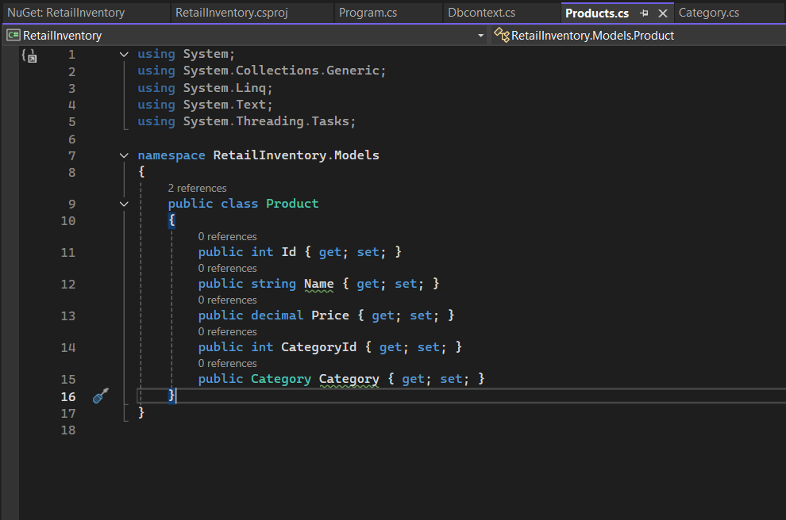

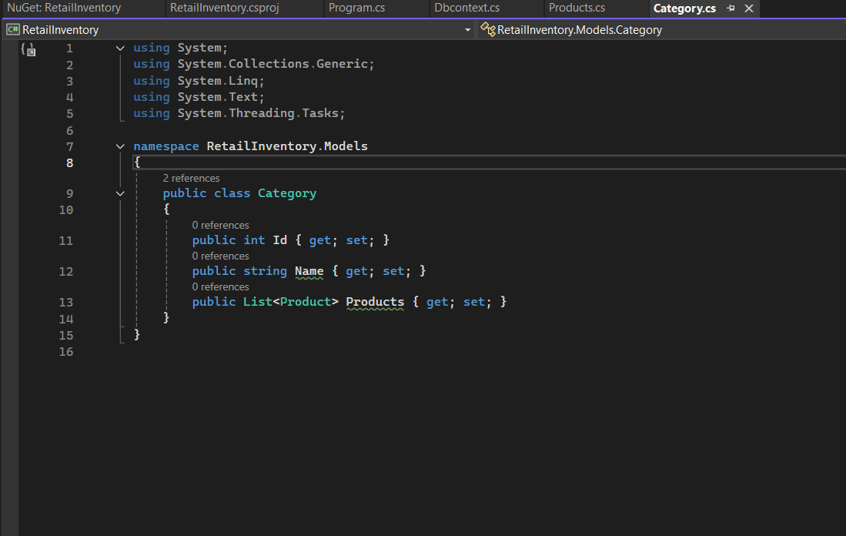

**2.Create AppDbContext:**

